NATIONAL INSTITUTE OF TECHNOLOGY AGARTALA
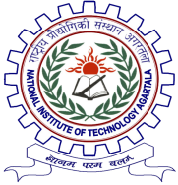

GUIDELINES FOR PREPARATION OF
THESES/DISSERTATIONS/REPORTS

FOR

Ph.D./M.Tech./ B.Tech./
DUAL DEGREE(B.Tech. + M .Tech.) /M.Sc./Integrated M.Sc./ MBA/ MCA Students

